**Navigating the Events (Calendar) Page of our Website**

The Calendar of Events of our new Website can be found in the **Events** Tab on the Website Header and Footer

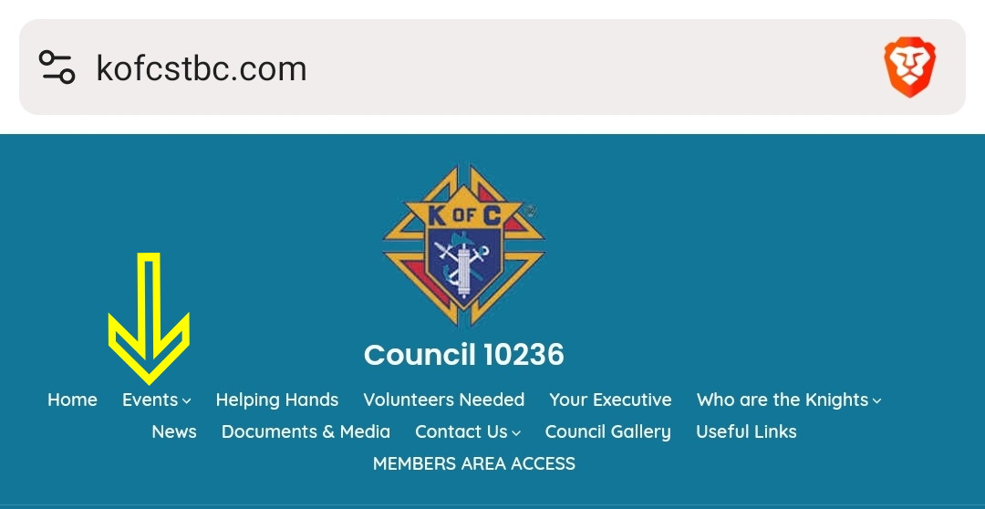

When you click on the Tab, the Calendar will open in the form of a chronological list of scheduled events

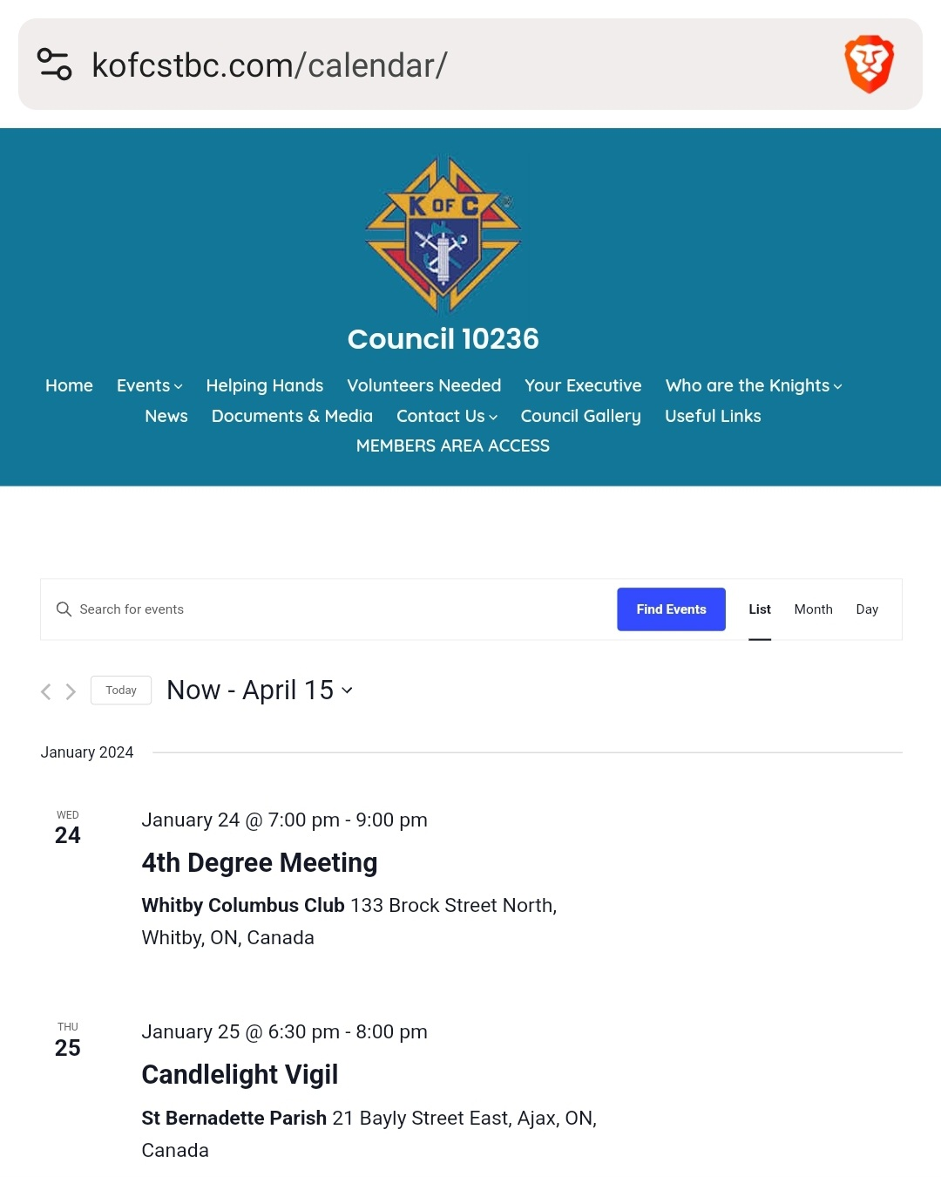

To see the Calendar in Month format, simply click the **Month** Tab at the top right hand corner of the Calendar. This will display the Calendar for the current Month.

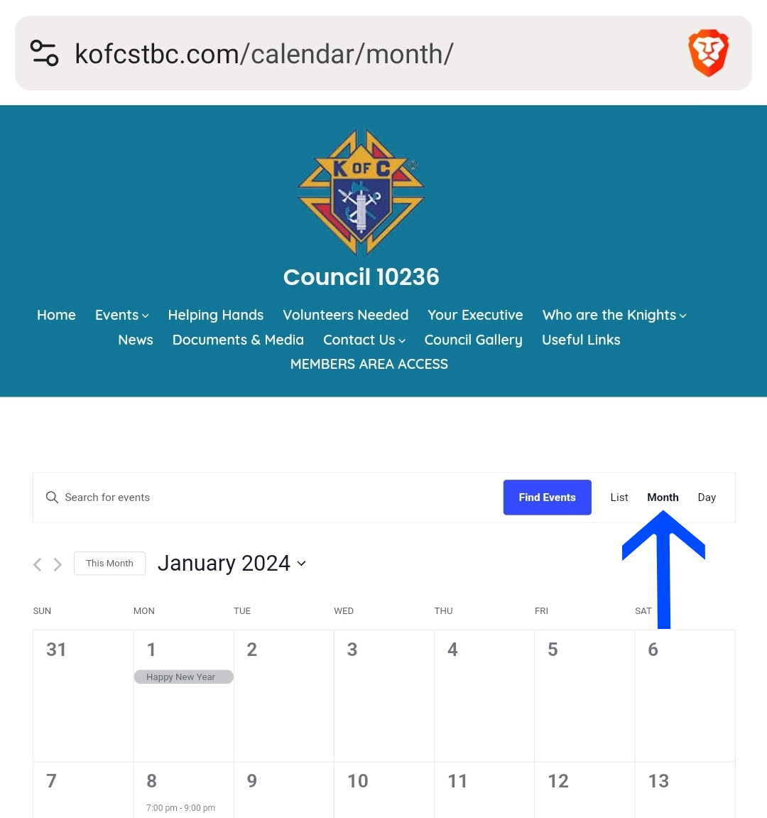

The display options include: List, Month, and Day.

If you wish to display other months, simply click on the Month/Year, for example **January 2024**, at the top left hand corner, and pick the month you want to display.

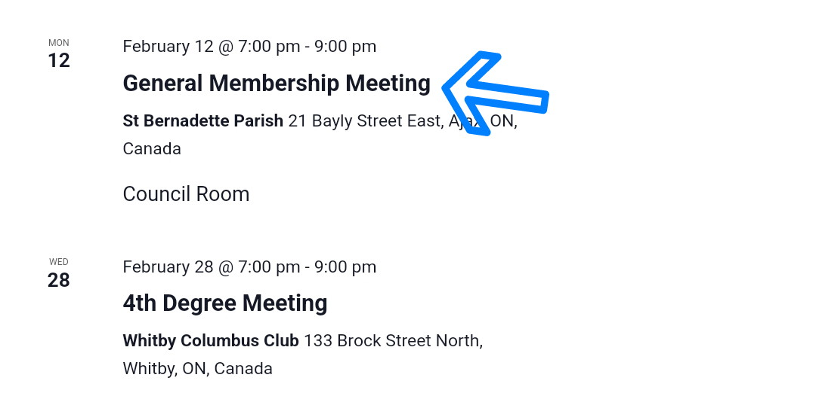

To get more details about a particular event, simply click on the highlighted name of the event.

A window showing the time, place, event details, and a Google Map wowing the location of the event will pop up.

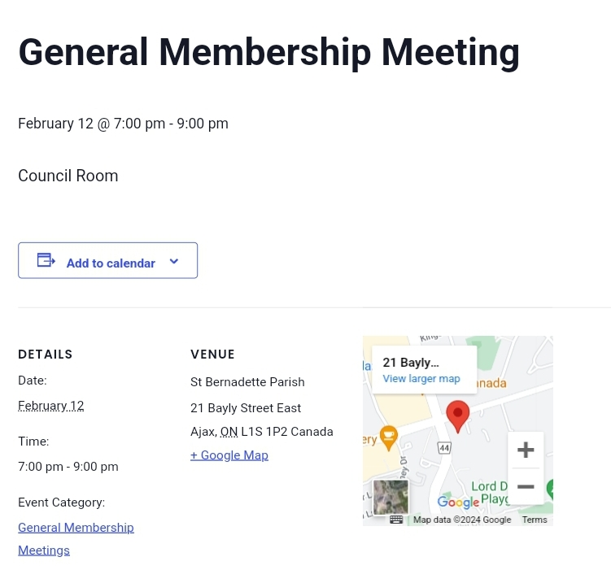

You so have the option to download the Knights Calendar to your favourite desktop/mobile/iPad Calendar App! To do this, click on the **Subscribe to calendar** button at the bottom right hand corner, and click on your device calendar format.

Options include:

* Google Calendar
* iCalendar
* Outlook 364
* Outlook Live
* Export .ics file
* 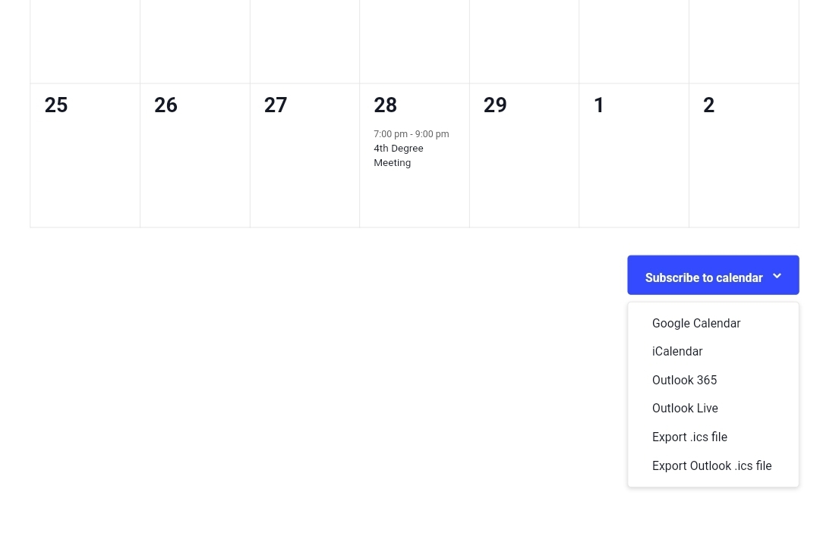Export Outlook .ics file