**REGISTERING FOR ACCESS TO THE MEMBERS AREA**

**GUIDELINES**

If you haven’t yet registered to access the Members Area of our Council Website or if you have forgotten your password you must contact the Communications Committee.

**Note:** If you run into any difficulties with this process, please send a detailed message including your

Mobile/Landline Number to [**kofcstbc@gmail.com**](mailto:kofcstbc@gmail.com).

**PROCEDURE:**

1. Send an email including your Full Name and Mobile Number to [**kofcstbc@gmail.co**](mailto:kofcstbc@gmail.co)**m.**

**Note:** If you don’t have a Mobile Number, include your Home Number instead and indicate that

it is a Landline.

1. Please allow **2 to 5 business days** for your request to be processed.
2. You will receive a secure email from [kofcstbc@gmail.com](mailto:kofcstbc@gmail.com) with instructions on how to get the password.

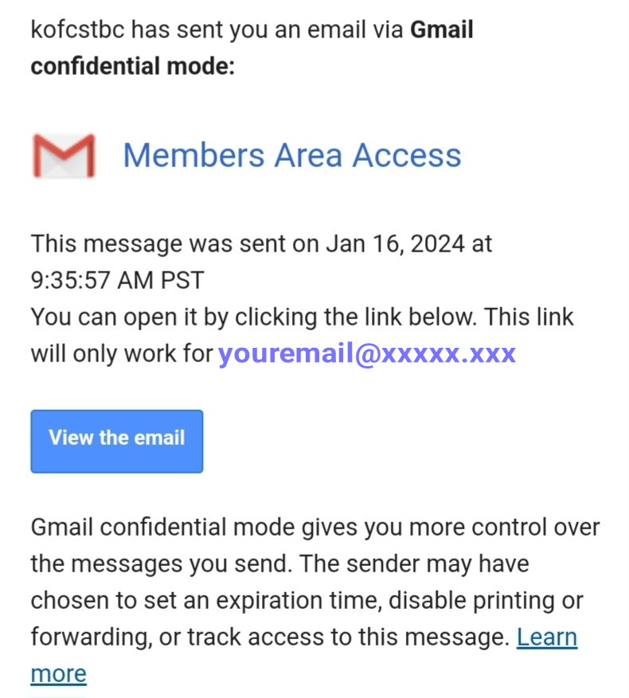

1. Click on the “View the email” button.
2. The following message will be displayed.

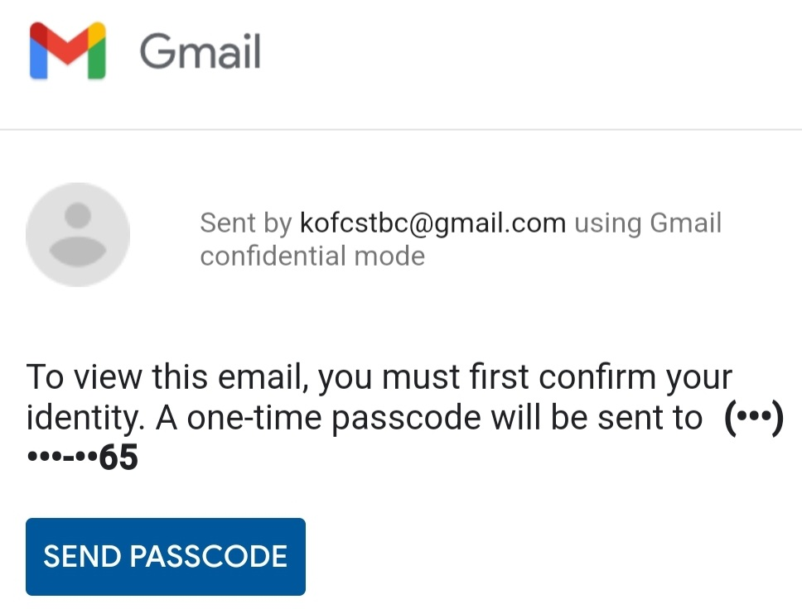

1. Click on the “SEND PASSCODE” button.
2. You will then receive an SMS with a PASSCODE.

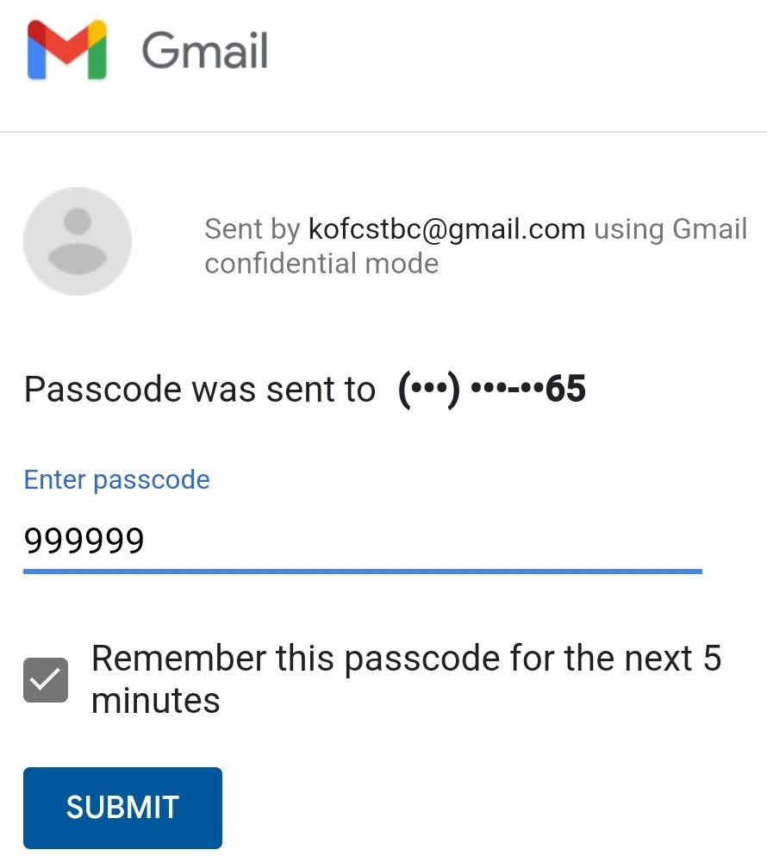

1. Enter the PASSCODE you received and click the “SUBMIT” button.
2. A screen with the Password for the Members Area will be displaced.

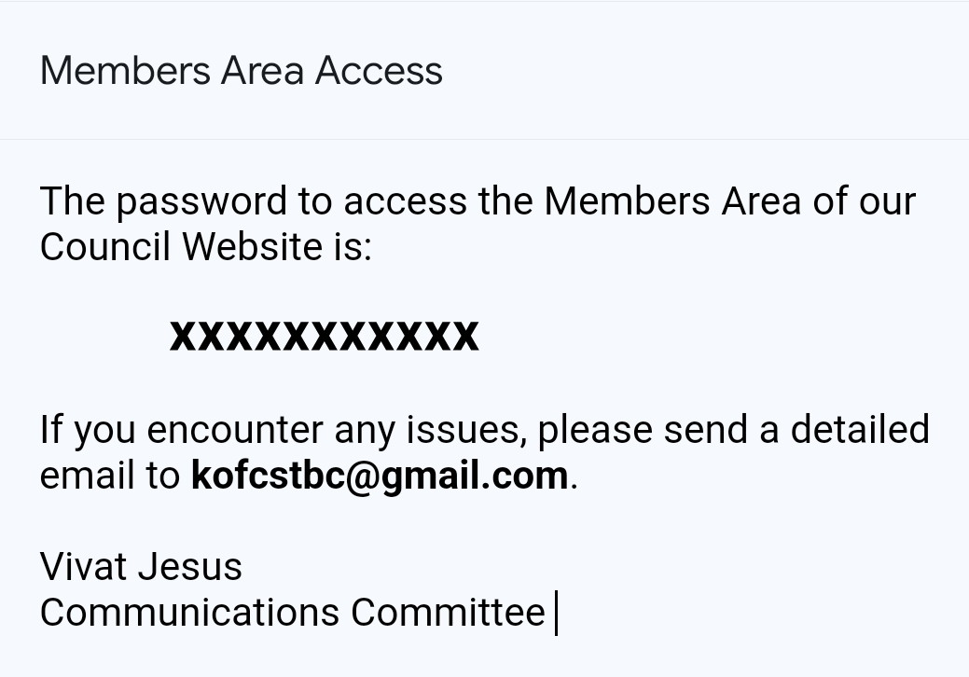

**Note:** Please add our email address ([kofcstbc@gmail.com](mailto:kofcstbc@gmail.com)) to your recipients list and check your

Spam Folder if you haven’t received a reply from us within 5 business days.